Lab Report No 03
De-Morgan's Theorem
________________________



CS-202L-Digital Logic Design Lab
Department of Computer System Engineering
University of Engineering and Technology Peshawar

Group No 5

Submitted by:
Muhsin Shah (2018)
Muhammad Zaid (1991)
Muhammad Saad (1997)

DCSE, Batch 23, Section “B”

Submitted to: Engr. Rehmat Ullah

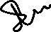
Objective:
- The objective of this lab is to practically prove the De-Morgan's theorem.
Apparatus:
- 9 volt battery
- Breadboard
- Connecting wires
- LED
- Logic Gates ICs
    - NOT gate 7404
    - OR gate 7432
    - AND gate 7408
    - NOR gate 7402
    - NAND gate 7400

De-Morgan’s Theorem:
This theorem gives the relation between AND gate and OR gate. Following are the two equations.
(A + B)’ = A’ . B’ ….(1)
(A . B)’ = A’ + B’ ....(2)

Procedure:
- We have two expressions to prove and each expression has two sides L.H.S and R.H.S.
- We will do this practicle on a breadboard and will use Dip switches for ON and OFF (0, 1) for the gates.
- Two switches from Dip switch will be used and the two input from each will be taken to the gates. One pair of two to the L.H.S and one to the R.H.S.
- At the output of the gates two LEDs will be connected. If both LEDs show the same output, then this will mean that De-Morgan’s theorem has proven.

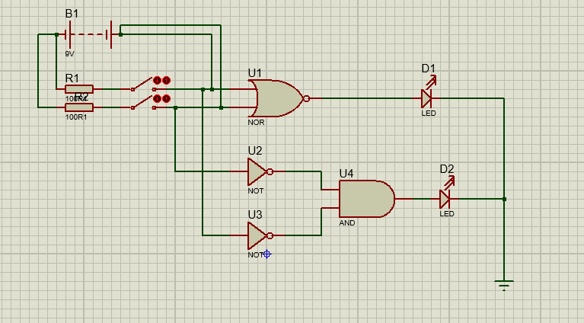

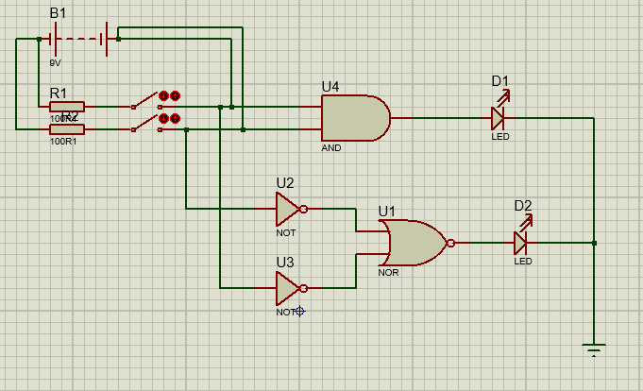

Procedure:
- First we will power on our power supply and connect two wires from it to our circuit board, one 5 volts and one ground or 0 volt.

- Then we will start our testing by taking inputs from 5 volts or 0 volt as high and low respectively and connect them to the input of the gates. In case of NOT gate there is only one input and for every other gate there are two.

- After this we will take output of the gate and connect it to the LED,s positive leg and other one is already grounded.

- All the gates should give the result according to the truth table i.e where there is “1” in the truth table, the LED will glow and “0”, it will not glow. Following are the results that we found for some gates in Lab while doing the experiment.

Exclusive OR (XOR) gate:
Standalone IC for XOR gate is rare. But it can be made by using AND, OR and NOT gates. Below is the circuit diagram for XOR gate and also the truth table of the results from the experiments performed.
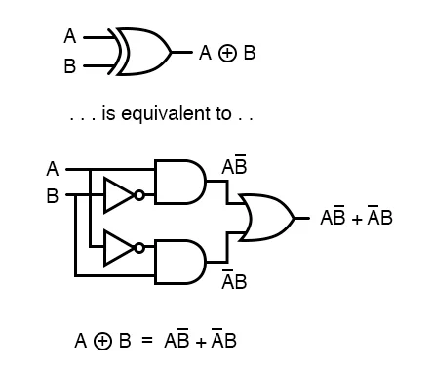
A | B | F(A, B)
0 | 0 | 0
0 | 1 | 1
1 | 0 | 1
1 | 1 | 0
XOR Gate Readings

_{Fig 03: XOR gate Circuit}

For 1 the LED glows and for 0 it does not.

